Hi Sunny –

The new sites are definitely at the point where they can be evaluated against each other. I have some ideas on how to enhance each and I am accumulating a list of notes that I should be able to send over in the new couple of days. In the meantime, I’m hoping to actually build one additional site for consideration (based off the Geek template).

The Geek template I’d like to use for this site is the following format:

<https://demo.themeregion.com/geek/index-two.html>

Buttons / Navigation



For this version, I’m aiming to simplify the navigation by having only four choices available to click. By having only four choices, that means we’ll be able to reduce the number of colors on the site, too. The four choices will be:

* Current CSI
* About CSI
* Proof Points
* Deeper Dive

The colors of these buttons should correspond to the same four colors we have been using for CSI. An example could be:

* Current CSI: 92D050
* About CSI: FFFF00
* Proof Points: FF3333
* Deeper Dive: 00B0F0

Additionally, I have made a new version of the logo where the background color is the same “gunmetal” gray as the theme utilizes in other places. The new logo can replace the avatar image and “Surzil Geek” that currently exists in the navigation.

Anchor links

The anchor links can link to the first chart for each section since we’re reducing the total number of links. Therefore, the anchor links will correspond with the following placements:

* Current CSI: CSI Chart
* About CSI: (should link to section that starts with “The Cyclical Strength Index (CSI) is a proprietary, data-driven […]”
* Proof Points: Double bar chart comparing S&P 500 and CSI cumulative performance (AVOIDING Q3 CREATES 35.6% BETTER RETURNS)
* Deeper Dive: Option Accuracy Chart (CSI vs. Black-Scholes Model)

Individual Sections

I would like to try a new formatting approach for each of the individual sections of the site. The website that has a similar approach I’m aiming for is: <http://oscarfour.varofthemes.com/> - I’ve included a screenshot below of the specific style:

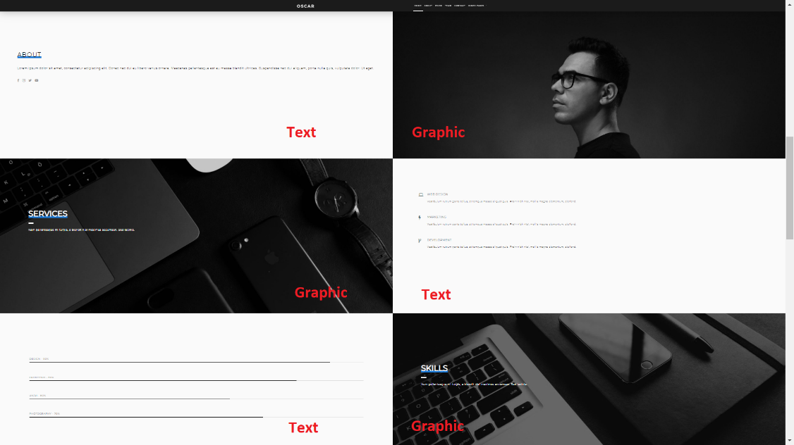

I’ve been searching for a way to better differentiate each section so they’re most distinguishable than using only a think gray line… and I think this may be a suitable approach. I have created a rough mockup of what ours could look like…

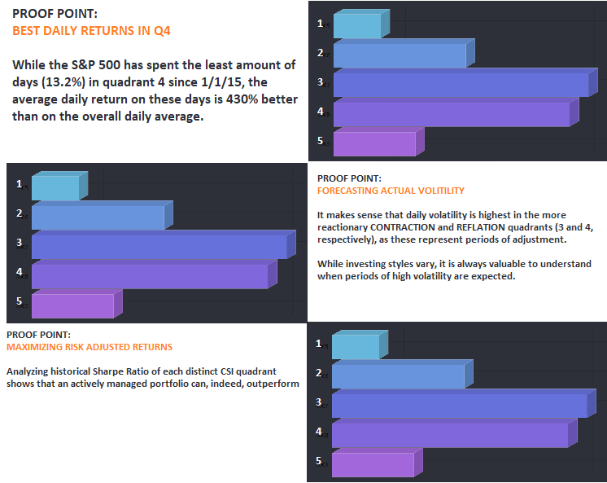

I didn’t put much thought/effort into font size and positioning, and the labels are off… but I think this does a decent job representing things, at least conceptually.

There’s a few things to note here…

The color I used for the background and text is not black, but its instead the dark gray that came with the theme. The hex code for this particular gray is: 2D3038

Also, when charts have a background color of gray, can all the text please be white?

My goal with this next prototype is to reduce the amount of total colors… so I figure using our four CSI colors, plus the gray and white, will cut down our total colors by at least a few.

Charts –

The background color for all the charts will now be the gunmetal gray color… and text will be in white. The small annotations that are in green or red, these can remain in green/red.

Horizontal bar charts –

For this version, I’m hoping we can implement the newer horizontal bar charts that will be in the sections for Daily Returns, Volatility and Risk Adjusted Returns.

Double bar chart

Can we make a few adjustments to the double bar chart please (S&P vs CSI Quadrants Historical Returns)? These changes can be implemented for all the prototypes, but no need to both on the others if it’s a lot of work.

Modifications:

1 - Can we change the colors for the bars in the double bar chart to white (since the background will now be gray, I think they will “pop” better if in white)?

2 – Can the text within each bar be changed to also include the label ?

* S&P 500 Total Returns
* CSI Quadrants Total Returns

3 – Can Quadrant 3 be disabled by default when the chart initially loads?

Top Section

I’ve labeled the top section in the screen short below:

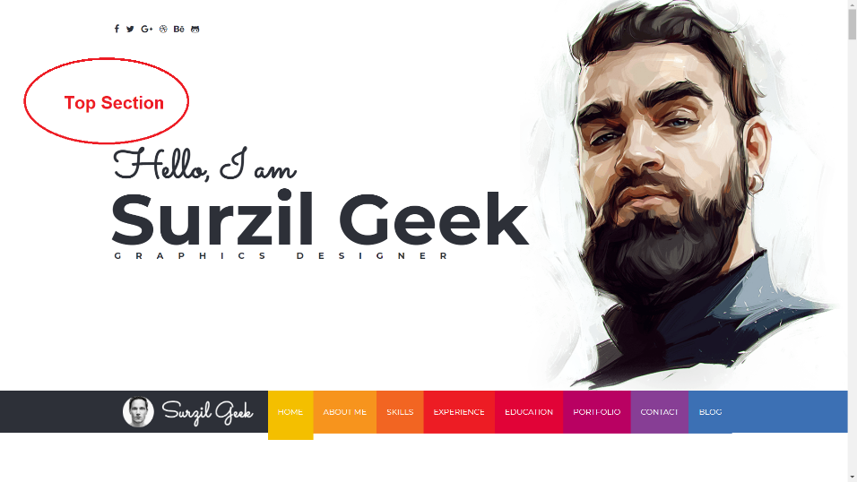

I’m not totally sure what to do with this section to be honest. Can the section, for now, just be made to be blank white color? (its ok for the social media icons in the top left to remain)